Math 3307

Name:

Instructions and penalties
Write your name above. 5 points off if anonymous

Write your answers in dark blue or black ink. 5 points off if I can’t read it.

Check your pdf. Make sure it’s right side up, in order and printable. There will be various penalties if I have to contact you for second copies that I can print.

Don’t turn it in late. 5 points off for late finals.

Use this form. If you chose not to, put the point values on each problem as they are in this form. 7 points off if you leave off the point values.

Question 1 16 points
You want to do an 82% confidence interval for some data about means. You’ve got your data and your formula all set. Show all the work associated with getting that critical z-score to put in your formula; every little detail of your work should be shown. All I want is z crit and the steps you took to get it for an 82% confidence interval.

Question 2 18 points
Here is a graph of the Inverse Gamma Distribution:
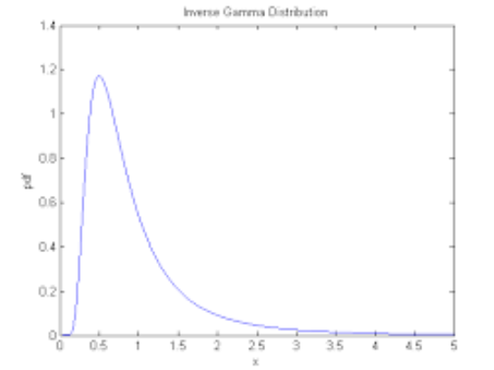
Write a small list comparing and contrasting this distribution to the Standard Normal Distribution. How are they alike? What are some differences? You should only focus on facts from this class and what you know about distributions in general and the Standard Normal in particular.

Problem continued on the next page:
If you took 1,000 sample sets from the Gamma Distribution with 56 elements per sample set, what would the distribution of the sample means from these samples look like? What would you know about the mean of this distribution of sample means and the standard deviation of it?

Question 3 15 points
You are in the market to buy a vintage Ford Mustang to fix up. You do your research and find that a sample of 100 of these fixer-uppers listed in various auto magazines has a sample mean of $5300 with a standard deviation of $550 as the going price. Produce a 90% confidence interval for the amount you’re going to have to save up to buy yours and discuss where the true price you’ll pay might be. The critical z-score is 1.645. Show the formula and all your work, plus the finished confidence interval.

Question 4 12 points
Produce a box and whiskers chart with fences for this data. Here’s the data for inches of rainfall on the 10th of April for 20 years in Houston:
3, 4, 4, 5, 1, 4, 3, 0, 5, 1, 6, 3, 3, 5, 3, 4, 6, 8, 5, 11

Question 5 20 points.
Give short answers to the following questions.
5A According to the U.S. Department of Justice the mean age of a death row inmate in 1980 was 36.7 years. A district attorney feels that the mean age is different now. What are the null hypothesis and the alternate hypothesis for a test of this feeling?

5B We have an alternative hypothesis that states , is this one-tailed or two? If the alpha is 10%, where is the rejection region? Produce a labled sketch assuming a normal distribution.

5C We have a confidence interval centered at 3, stretching from 1 to 5. What is the error bound of the interval? Show it on an interval and label it.

Continued on next page

5D The Empirical Rule applies to every distribution in the whole wide world: true or false. How do you know you’re right?

5E In a random sample from a given population, each element in the population has an equally likely chance of being chosen. Why is “random” important when selecting elements of a data set?

Question 6 19 points
A researcher claimed that the average age of a woman before she has her first child is greater in 1999 than the 1990 mean of 26.4 years. She obtained a simple random sample of 49 women who gave birth in 1999 and finds the sample mean to be 27.1 years with a standard deviation of 6.4 years.
Test the researcher’s claim with a 5% level of significance. Write your decision clearly.

Extra credit 10 points
Here is a chart for residents of the USA, aged 18 or older in 1998. The numbers are in millions.
 | Male | Female
Never  Married | 25.5 | 21.0
Married | 58.6 | 59.3
Widowed | 2.6 | 11.0
Divorced | 8.3 | 11.1

A Compute the probability that a randomly selected male has never been married.

B Compute the probability that a randomly selected individual who has never been married is male.

